**DeepLabCut Manual by Jesse Groot**

1. DeepLabCut will be used on the UvA cluster to extract coordinates from objects/animals in videos. Watch out everything is capital sensitive (K/k).
2. In the cluster the one map has to be made in the /data/ folder with your user name and within this map 2 folders with the name: videos (where the videos will be stored that you want to analyze) and projects (explained later)
3. Within the video map the videos have to be in their own folder  
   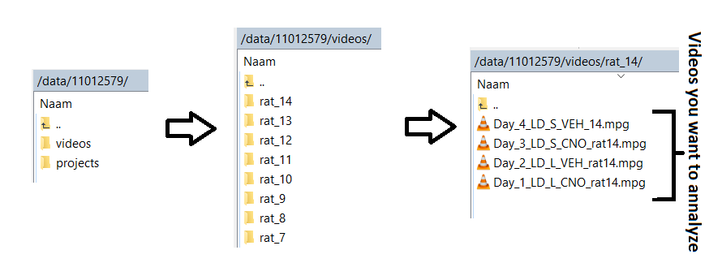
4. 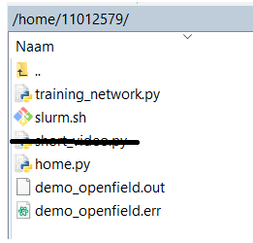Within the /home/ folder you have to make a file with you name (same as in /data/) you will need the following files within this folder as you can see below which can be found on: <https://github.com/jessegroot/DeepLabCut> --> last 2 are empty folders which you can make yourself
5. Now open the .py and .sh files in bv. Atom. Than control+f and replace all 11012579 with your own username.
6. 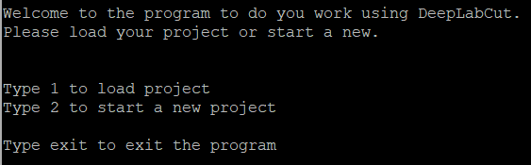When this is saved you can open Putty 🡪 connect to the server 🡪 run:   
   source /data/conda/bin/activate dlc 🡪 run: ipython home.py 🡪 following will appear:
7. Type 2 to start a new project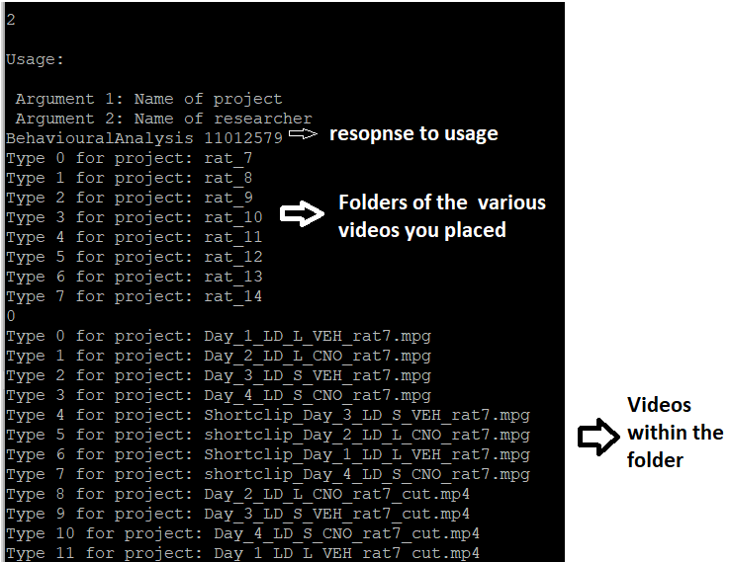
8. Choose one the other videos will be added later. Than this will appear: type check if correct  
   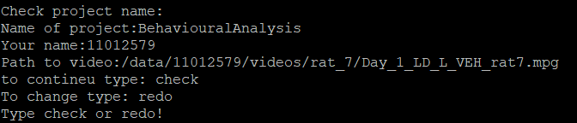
9. Than you will get the following instruction:  
   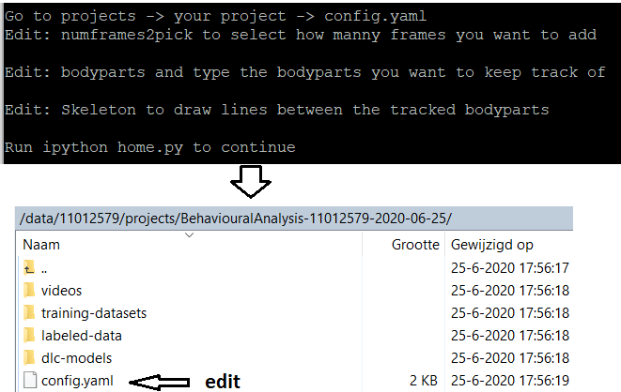

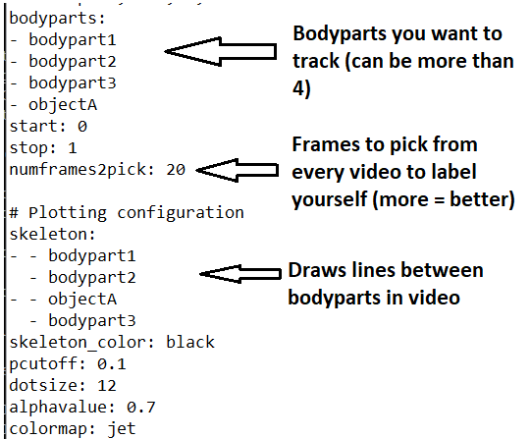than

1. 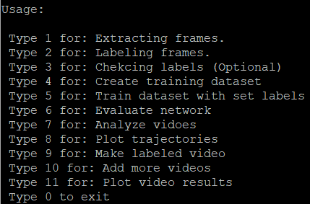Now you can use deeplabcut to do the following by following the given instruction: